Our Vision
A world where everyone has a decent place to live.
Our Mission
Seeking to put God’s love into action, HFHEB of Sheridan County brings people together to build homes, communities and hope.
Homeownership Program
HFHEB helps low-income families in need of decent, affordable housing become homeowners. Every day we work with families and volunteers to build strength, stability, self-reliance and shelter. We envision a world where everyone has a decent place to live. Join us as we dig in, get dirty and lift others up.
Home Sponsorship Program
Corporate partner’s financial donation will go toward the construction materials for homes across Sheridan County. Sponsorship is an opportunity to support hard-working, low-income families to make their dream of homeownership become a reality. Volunteering alongside Habitat families while they earn “sweat equity” toward their new home is an enriching experience.
In addition to a financial investment in the construction of a home, sponsors receive multiple partner benefits. Companies increase their reputation in the community as a socially responsible corporation. Through volunteer engagement you will experience valuable team building activities for employees. This will enhance staff retention and productivity, as well as diverse benefits with marketing, public relations and social media outreach.
Sponsorship Levels: Construction Program
Title Sponsor – $50,000
Home Sponsor – $25,000-49,999
Foundation Sponsor – $10,000-24,999
Material Sponsor – $5,000-9,999
Roof Sponsor – $2,500-4,999
Wall Sponsor – $1,000-2,499

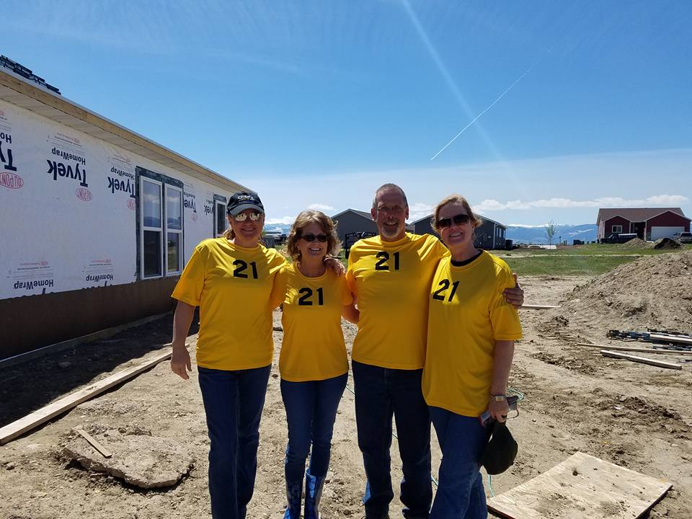
HFHEB Volunteers
From Century 21 BHJ Realty during our Realtors Build Week

Marketing and Publicity Benefits | Title Sponsor | Home Sponsor | Foundation Sponsor | Material Sponsor | Roof Sponsor | Wall Sponsor
Present homeowners with gift | X
Speaking opportunity at groundbreaking ceremony | X | X
Habitat-issued press release | X | X
Website recognition with link to sponsor’s website | X | X | X
Logo listed on our website’s  home page | X | X | X
Permission to use Habitat’s logo  for one year | X | X | X | X
Logo on Habitat build day t-shirts | X | X | X | X
Logo on construction sign at  build site | X | X | X | X
Logo in dedication ceremony program | X | X | X | X
Name on construction sign at  build site |  |  |  |  | X | X
Name in dedication ceremony program |  |  |  |  | X | X
Logo listed on Habitat  sponsor page | X | X | X | X | X | X
Recognition in Annual Report | X | X | X | X | X | X
Priority build dates reservations | X | X | X | X | X | X
Special Event Benefits
Logo in program for all events | X
Speaking opportunity at  annual events | X | X | X
Complimentary tickets to  annual event(s)* | X | X | X | X | X | X
Complimentary tables at  annual event(s)* | X | X | X | X | X | X
Social Media Benefits
Volunteer photo album on Habitat’s Facebook page | X
Minimum of 3 social media posts | X | X
Minimum of 2 social media posts |  |  | X | X
Minimum of 1 social media post |  |  |  |  | X | X
Volunteer Engagement
10 Build Days | X
7 Build Days |  | X
5 Build Days |  |  | X
4 Build Days |  |  |  | X
3 Build Days |  |  |  |  | X
2 Build Days |  |  |  |  |  | X
1 Build Day

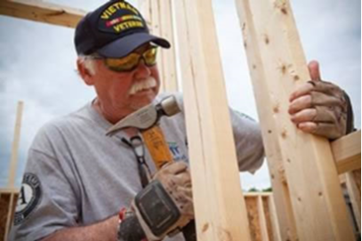
*The number of complimentary tickets, tables, and attendance to annual events differ per sponsorship level.

Title Sponsor – 2 tables at all annual events
Home Sponsor - 1 table at all annual events
Foundation Sponsor – 1 table to 2 annual events
Material Sponsor – 1 table to 1 annual event,
or 10 tickets to 1 annual event
Roof Sponsor – 4 tickets to 2 annual events,
or 8 tickets to 1 annual event
Wall Sponsor - 4 tickets to 1 annual event

